2/4/10


APEC - Funded Medical Devices Regulatory Harmonization Delegation Visit to Canada and the United States
August 8 - 18, 2010 • Ottawa, Canada; Boston, Massachusetts; and Washington D.C., USA

Health Canada, the U.S. Food and Drug Administration (USFDA), the Global Harmonization Task Force (GHTF), the Pan American Health Association (PAHO), the Latin American Harmonization Working Party (LAHWP), the Asian Harmonization Working Party (AHWP), the U.S. Department of Commerce (USDOC), and the Advanced Medical Technology Association (AdvaMed) present the latest in the series of APEC-funded projects educating regulators on global harmonization of medical devices regulation. AdvaMed will coordinate with U.S. and Canada industry in organizing the industry portion of this delegation visit.
Participation in this delegation visit will help you as a regulator to better understand global medical device regulations and the emerging similarities between them. This delegation visit builds upon a similar APEC-funded September 2009 delegation visit of APEC Asia medical devices regulators to Australia. The focus of the August 2010 delegation visit will be training, laboratory visits, and training conducted by regulatory government and industry regulatory experts involved in GHTF, with a concentration on how two of the GHTF founding members (Health Canada and USFDA) implement their regulatory regime including auditing, quality system and surveillance. English – Spanish simultaneous translation will be provided during all training activities and firm visits. While this August 2010 delegation visit to Canada and the United States is an APEC-funded project, with focus on Latin American APEC economies, all APEC economies are welcome to participate. APEC has also authorized the following non-APEC economies to participate - Argentina, Bolivia, Brazil, Colombia, Costa Rica, El Salvador, Honduras, Nicaragua, Panama, Uruguay, India, Laos, and Cambodia.
See the schedule of activities during the delegation visit listed on page two of this announcement. The trainers during this delegation visit will make presentations, participate in panel discussions, lead group discussions and present case studies. Due to space limitations we will need to limit the total delegation size to 30 regulators. While this will be essentially done on a first-come first-serve basis, we may need to limit the number of regulators per economy if more than 30 regulators register, so the registration deadline is important.
Who should attend the Workshop?
Representatives from:
- APEC member economies with established or developing medical regulatory systems
- Non APEC member economies with established or developing medical regulatory systems
(APEC has authorized limited non-APEC Asia regulators participation from the following economies Argentina, Bolivia, Brazil, Colombia, Costa Rica, El Salvador, Honduras, Nicaragua, Panama, Uruguay, India, Laos, and Cambodia).
Workshop’s objectives:
- Understanding GHTF recommendations on issues relating to regulation, auditing, quality systems and surveillance
- Practical training sessions achieved through a smaller instructor to student ratio, using case studies and interactive discussion between instructors and students
- Providing guidance on the role of regulators, industry, and distributors in regulatory harmonization and securing the integrity of the medical devices supply chain.
LIMITED FUNDS FOR SUBSIDIZED TRAVEL
There are limited funds available for travel support (the cost of round trip economy-class airfare, lodging, and per diem costs) for two medical devices regulators from the three APEC Latin America economies: Mexico, Peru, and Chile. If you are a government official from one of these economies and you wish to be considered for the travel support available, please send an e-mail to Gerry Zapiain at gerry.zapiain@trade.gov and Jeffrey Gren at jeffrey.gren@trade.gov. Please include your name, position, agency or ministry, and full contact information. We will need this e-mail submitted no later than May 26, 2010. You will be notified if you are selected for the travel support by June 25, 2010.

In addition, the USDOC is seeking additional travel funds from APEC for two regulators from each of the following Asian APEC travel-eligible economies: China, Indonesia, Malaysia, Papua New Guinea, Philippines, Russia, Thailand and Viet Nam. If you are a government official from one of these Asia economies, please email your interest to Gerry Zapiain and Jeffrey Gren at the above email addresses. Upon approval of the funds requested from APEC, two regulators from each of these Asia economies will be considered for travel subsidies on a first-come, first-served basis.

LIMITED FUNDS FOR SUBSIDIZED TRAVEL
Subsidized Travel Support for Latin American APEC Regulators - There are limited funds available for travel support (the cost of round trip economy-class airfare, lodging, and per diem costs) for two medical devices regulators from the three Latin America APEC economies: Mexico, Peru, and Chile. If you are a government official from one of these three Latin American APEC economies and you wish to be considered for the travel support available, please send an e-mail to Gerry Zapiain at gerry.zapiain@trade.gov and Jeffrey Gren at jeffrey.gren@trade.gov. Please include your name, position, agency or ministry, and full contact information. We will need this e-mail submitted no later than May 26, 2010. You will be notified if you are selected for the travel support by June 25, 2010.
Subsidized Travel Support for Asian APEC Regulators - The USDOC is seeking additional travel funds to enable a limited amount of funding for regulators from the following Asian APEC travel-eligible economies: China, Indonesia, Malaysia, Papua New Guinea, Philippines, Russia, Thailand and Vietnam. If you are a medical devices regulator from one of these Asia economies, please e-mail your interest to Gerry Zapiain and Jeffrey Gren at the above e-mail addresses. For the responses received from eligible Asia APEC regulators we will note your interest and we will send you an announcement if the additional funds become available. Of course, all APEC Asia economies can self fund participants.

APEC - Funded Medical Devices Regulatory Harmonization Delegation Visit to Canada and the U.S.
August 8 - 18, 2010 • Ottawa, Canada; Boston, Massachusetts; and Washington D.C., USA

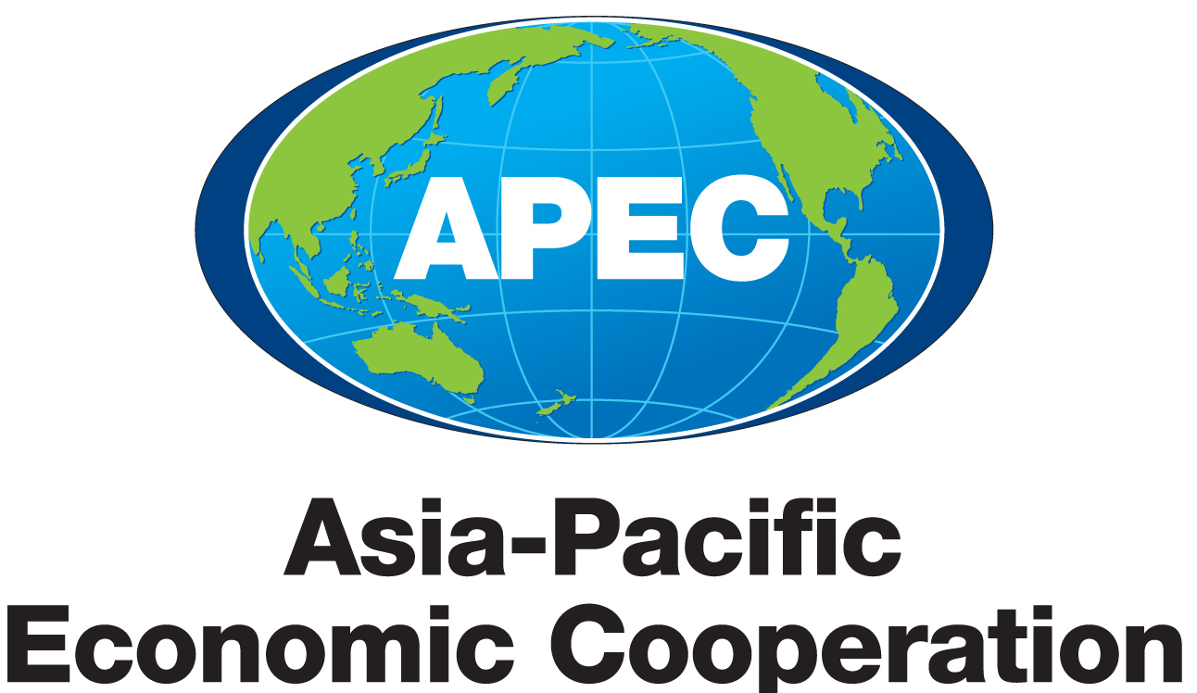

AGENDA

Sunday, August 8
6:30 pm - 8:30 pm Informal Dinner at (to be determined)
(No-host, optional for those attending at their own cost)
Monday, August 9
8:30 am - 9:00 am Registration

9:00 am - 5:00 am Training Program Conducted by Health Canada

Tuesday, August 10
9:00 am - 5:00 am Training Program Conducted by Health Canada
7:30pm - 9:30 pm Possible US DOC hosted dinner

Wednesday, August 11 Travel from Ottawa to Boston and free time (delegation members will be required to book their own travel reservations, and recommended flights will be provided in advance)
Thursday, August 12
8:30 am - 5:00 pm Industry Portion of the Training Program for Two Days to be Coordinated by AdvaMed in Boston
Friday, August 13
8:30 am - 5:00 pm Training Program and Company Visits Coordinated by AdvaMed

7:30 pm - 9:30 pm Reception/Dinner Hosted by Industry

Saturday, August 14 Travel from Boston to Washington DC and free time in Washington DC (delegation members will be required to book their own travel reservations, and recommended flights will be provided in advance)

Sunday, August 15 Sightseeing in Washington, DC

Monday, August 16
9:00 am - 5:00 pm Training Program Conducted by US Food and Drug Administration and hosted at the USDOC

Tuesday, August 17
9:00 am - 5:00 pm Training Program Conducted by US Food and Drug Administration and hosted at the USDOC

6:30 pm - 8:30 pm Reception/Dinner Hosted by Industry

Wednesday, August 18
8:30 am - 5:00 pm Training Program Conducted by US Food and Drug Administration and hosted at the USDOC

APEC - Funded Medical Devices Regulatory Harmonization Delegation Visit to Canada and the U.S.
August 8 - 18, 2010 • Ottawa, Canada; Boston, Massachusetts; and Washington D.C., USA

REGISTRATION FORM

To register for the delegation visit, please email or fax this registration form (two pages) to:

Gerry Zapiain
US Department of Commerce, Office of Health and Consumer Goods
Washington DC 20230, Room 1015

Tel: +011 202 482 2410
Fax: +011 202 482 0975
Email: Gerry.Zapiain@trade.gov

A. Participant’s Information Mr. ___ Mrs. ___ Ms. ___ Dr. ___ Prof. ___

Last Name: _____________________________________ First Name: ___________________________________________

Title/Position:________________________________

Organization/Country: ___________________________________ _____________________________________________

Tel: ____________________________________________ Fax: __________________________________________________

Mailing Address: ______________________________________________________________________________________

_______________________________________________________________________________________________________

Email: ____________________________

B. Your confirmation on the following dinner arrangement is required.

Dietary Requests: Vegetarian □ Beef Free □ Pork Free □ None □ Others □_____
I will attend the official hospitality dinner on August 11 Yes □ No □
I will attend the industry hospitality dinner on August 13 Yes □ No □
I will attend the industry hospitality dinner on August 17 Yes □ No □

APEC - Funded Medical Devices Regulatory Harmonization Delegation Visit to Canada and the U.S.
August 8 - 18, 2010 • Ottawa, Canada; Boston, Massachusetts; and Washington D.C., USA

REGISTRATION FORM (continued)

REGISTRATION
The last day for registration is June 15, 2010. There is a limited capacity for participants during the delegation visit. Attendees will be accepted on a space-available basis. All hotel rates quoted below are in Canada or US dollars.

HOTEL RESERVATIONS (to be added)
- Ottawa –

- Boston –

- Washington DC –

Please note that bookings have been made with the above hotels for the workshop attendees. However, you are required to finalize your hotel reservation by contacting each of the hotels directly using the information provided below. You will be asked to provide your credit card details and quote the group booking reference codes by the respective hotel staff to secure your booking.

The above special room rates apply for reservations made by----------. After this date, availability cannot be guaranteed and prevailing room rates will apply.
□ I will be staying at the ----------- in Ottawa. I will check in on August ____, Checkout is August 11 and I agree to confirm my room booking directly with the hotel.
□ I will be staying at the ………… in Boston. Check in is August 11, check out is August 14, and I agree to confirm my room booking directly with the hotel.
□ I will be staying at the ………… in Washington DC. Check in is August 14 and I will be checking out on August ___. I agree to confirm my room booking directly with the hotel.

After the group reservations expires on ……….., it will be your own responsibility to find a suitable hotel for your stay in Ottawa, Boston or Washington DC.

LIMITED FUNDS FOR SUBSIDIZED TRAVEL

Subsidized Travel Support for Latin American APEC Regulators - There are limited funds available for travel support (the cost of round trip economy-class airfare, lodging, and per diem costs) for two medical devices regulators from the three Latin America APEC economies: Mexico, Peru, and Chile. If you are a government official from one of these three Latin American APEC economies and you wish to be considered for the travel support available, please send an e-mail to Gerry Zapiain at gerry.zapiain@trade.gov and Jeffrey Gren at jeffrey.gren@trade.gov. Please include your name, position, agency or ministry, and full contact information. We will need this e-mail submitted no later than May 26, 2010. You will be notified if you are selected for the travel support by June 25, 2010.

Subsidized Travel Support for Asian APEC Regulators - The USDOC is seeking additional travel funds to enable a limited amount of funding for regulators from the following Asian APEC travel-eligible economies: China, Indonesia, Malaysia, Papua New Guinea, Philippines, Russia, Thailand and Vietnam. If you are a medical devices regulator from one of these Asia economies, please e-mail your interest to Gerry Zapiain and Jeffrey Gren at the above e-mail addresses. For the responses received from eligible Asia APEC regulators we will note your interest and we will send you an announcement if the additional funds become available. Of course, all APEC Asia economies can self fund participants.

