

APEC - Funded Asian Medical Devices Regulatory Harmonization Delegation Visit to Australia
September 20 - 25, 2009 • Canberra and Sydney, Australia

The Australian Therapeutic Goods Administration (TGA), together with the Medical Technology Association of Australia (MTAA), the Asian Harmonization Working Party (AHWP), and the U.S. Department of Commerce, presents the latest in the series of APEC funded projects educating regulators on global harmonization of medical device regulation. Participation in the Asia delegation visit will help you as a regulator better understand global medical device regulations and the emerging similarities between them. The focus of the delegation visit will be training, laboratory visits, and training conducted by regulatory government and industry regulatory experts involved in the Global Harmonization Task Force (GHTF), with a concentration on how one of the GHTF founding members (Australian TGA) implements their regulatory regime including auditing, quality system and surveillance issues.
APEC has approved funding for a project to take place during 2009 and 2010 consisting of delegation visits of APEC medical devices regulators to APEC economies with developed medical devices regulatory regimes. This project will consist of an Asia medical devices regulatory delegation visit to Australia (September 20 – 25, 2009) and a Latin America delegation to the U.S. and Canada (May 2010). This announcement is for the Asia delegation to Australia.
While this delegation visit to Australia is an APEC funded activity primarily for APEC economies, APEC has authorized the following non-APEC Asian economies to participate - India, Laos, and Cambodia.
The delegation visit will begin on Sunday night September 20 in Canberra, Australia, with an informal (no-host) welcome dinner. The Canberra portion of the program will include three days of training conducted by Australian TGA staff. The trainers during this delegation visit will make presentations, participate in panel discussions, lead group discussions and present case studies. On Wednesday evening, September 23, the Asian delegation will travel from Canberra to Sydney, Australia for two days of training including company visits (September 24 and 25) to be conducted by the Australian industry association (MTAA).
Who should attend the Workshop?
Representatives from:
- APEC member economies with established or developing medical regulatory systems
- Non APEC member economies with established or developing medical regulatory systems
(APEC has authorized limited non-APEC Asia regulators participation from the following economies Cambodia, India, and Laos)
Workshop’s objectives:
- Understanding GHTF recommendations on issues relating to regulation, auditing, quality systems and surveillance
- Practical training sessions achieved through a smaller instructor to student ratio, using case studies and interactive discussion between instructors and students
- Providing guidance on the role of regulators, industry, and distributors in regulatory harmonization and securing the integrity of the medical devices supply chain.

LIMITED FUNDS FOR SUBSIDIZED TRAVEL
There are limited funds available for travel support (the cost of round trip economy-class airfare, lodging, and per diem costs) for two medical devices regulators from the following APEC Asia economies: China, Indonesia, Malaysia, Papua New Guinea, Philippines, Russia, Thailand and Viet Nam. If you are a government official from one of these economies and you wish to be considered for the travel support available, please send an e-mail to Gerry Zapiain at Gerry.Zapiain@mail.doc.gov and Jeffrey Gren at Jeffrey.Gren@mail.doc.gov. Please include your name, position, agency or ministry, full contact information, and a short narrative on why you and your economy would benefit from your participation in the APEC seminar. We will need this e-mail submitted no later than June 26, 2009. You will be notified if you are selected for the travel support by July 10, 2009.

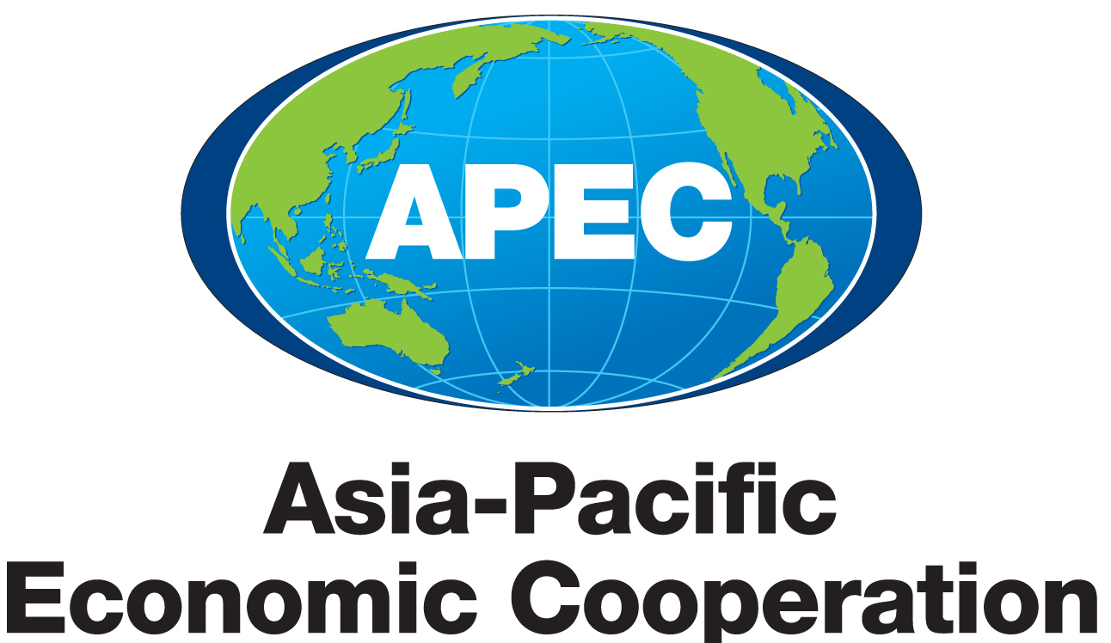
APEC - Funded Asian Medical Devices Regulatory Harmonization Delegation Visit to Australia
September 20 - 25, 2009 • Canberra and Sydney, Australia

AGENDA

Sunday, September 20
6:30 - 8:30 Informal Dinner at the Recommended Hotel in Canberra
(Buffet style, no-host, optional for those attending at their own cost)

Monday, September 21
8:30 - 9:30 Registration
9:30 - 17:00 Training Program Conducted by Australian TGA

19:00 - 21:30 Official Dinner Reception at the Recommended Hotel in Canberra

Tuesday, September 22
9:00 - 17:00 Training Program Conducted by Australian TGA

Wednesday, September 23
9:00 - 15:00 Training Program Conducted by Australian TGA

Leave Canberra to Sydney by Coach (about 3.5 hour)
Arrival in the Sydney Hotel Recommended

Thursday, September 24
8:30 - 17:00 Industry Portion of the Training Program for Two Days to be Coordinated by MTAA

This will include attendance at several workshops on Thursday, September 24 during the MTAA's Annual Conference. The workshop topics will be added to this event announcement, once they are identified. The industry portion will also include medical devices company visits organized by MTAA on Friday, September 25.

Friday, September 25
8:30 - 17:00 Training Program and Company Visits Coordinated by MTAA

19:30 - 21:30 Farewell Reception/Dinner Coordinated by MTAA

APEC - Funded Asian Medical Devices Regulatory Harmonization Delegation Visit to Australia
September 20 - 25, 2009 • Canberra and Sydney, Australia

REGISTRATION FORM

To register for the delegation visit, please email or fax this registration form (two pages) to:

The TGA International Training Coordinator
Executive Support Unit
TGA, PO Box 100, Woden, ACT 2609, Australia

Tel: +61-2-6232 8585
Fax: +61-2-6232 8469
Email: tga.international@tga.gov.au

A. Participant’s Information Mr. ___ Mrs. ___ Ms. ___ Dr. ___ Prof. ___

Last Name: _____________________________________ First Name: ___________________________________________

Title/Position:________________________________

Organization/Country: ___________________________________ _____________________________________________

Tel: ____________________________________________ Fax: __________________________________________________

Mailing Address: ______________________________________________________________________________________

_______________________________________________________________________________________________________

Email: ____________________________

B. Your confirmation on the following dinner arrangement is required.

Dietary Requests: Vegetarian □ Beef Free □ Pork Free □ None □ Others □_____
I will attend the official hospitality dinner on September 21 Yes □ No □
I will attend the farewell dinner in Sydney on September 25 Yes □ No □

APEC - Funded Asian Medical Devices Regulatory Harmonization Delegation Visit to Australia
September 20 - 25, 2009 • Canberra and Sydney, Australia

REGISTRATION FORM (continued)

REGISTRATION
Registration is on a first-come-first-serve basis. The last day for registration is July 24, 2009. There is a limited capacity for participants during the delegation visit. Attendees will be accepted on a space-available basis. All hotel rates quoted below are in Australian dollars including GST (Goods and Services Tax).

HOTEL RESERVATIONS
Special rates for three types of hotel accommodations at AUS $130 per night (single twin room) or AUS $175 (executive suite or one bedroom apartment) respectively for government organization employees are available at the Forrest Hotel and Apartments in Canberra.

Special rate for government organization employees at AUS $162 per night (a standard hotel room) is available at the Ibis Hotel Darling Harbour in Sydney.

Please note the TGA has made group bookings with both hotels for the workshop attendees. However, you are required to finalize your hotel reservation by contacting each of the hotels directly using the information provided below. You will be asked to provide your credit card details and quote the TGA’s group booking reference codes by the respective hotel staff to secure your booking.

Forrest Hotel and Apartments in Canberra
Address: 30 National Cct, Forrest, Canberra, ACT 2603
Phone reservation: +61-6295 3433
Fax: +61-2-6295 2119
Website: www.forresthotel.com
Reservation email: reservations@forresthotel.com
TGA group booking reference code: TG2009

The Ibis Hotel Darling Harbour in Sydney
Address: 70 Murray St, Pyrmont, Sydney, NSW 2000
Phone reservation: +61-2-9288 7180
Fax number: +61-2-9563 0899
Website: www.ibishotels.com.au
Reservation email: h1181-re33@accor.com
TGA group booking reference code: AFG230909

The above special room rates apply for reservations made by Friday, September 4, 2009. After this date, availability cannot be guaranteed and prevailing room rates will apply.
□ I will be staying at the Forrest Hotel and Apartments in Canberra. I will check in on September ____, Check-out is Wednesday, September 23. I agree to confirm my room booking directly with the hotel.
□ I will be staying at the Ibis Hotel Darling Harbour in Sydney. Check in is Wednesday, September 23, I will check out on September ____. I agree to confirm my room booking directly with the hotel.

After the TGA’s group reservations expired on Friday, September 4, 2009, it will be your own responsibility to find a suitable hotel for your stay in both Canberra and Sydney. Because of that, it will also be your responsibility to arrange your local ground transport to and from the meeting venues.

LIMITED FUNDS FOR SUBSIDIZED TRAVEL
There are limited funds available for travel subsidies (the cost of round trip economy-class airfare, lodging, and per diem costs) for two medical devices regulators from the following Asia APEC economies: China, Indonesia, Malaysia, Papua New Guinea, Philippines, Russia, Thailand and Viet Nam. If you are a government official from one of these economies and you wish to be considered for the travel support available, please send an e-mail to Gerry Zapiain at Gerry.Zapiain@mail.doc.gov and Jeffrey Gren at Jeffrey.Gren@mail.doc.gov. Please include your name, position, agency or ministry, full contact information, and a short narrative on why you and your economy would benefit from your participation in the APEC seminar. We will need this e-mail submitted no later than June 26, 2009. You will be notified if you are selected for the travel support by July 10, 2009.

